* What is the Activity Back Stack?
  + A task is a collection of activities that users interact with when performing a certain job. The activities are arranged in a stack (the back stack), in the order in which each activity is opened.
  + The device Home screen is the starting place for most tasks. When the user touches an icon in the application launcher (or a shortcut on the Home screen), that application's task comes to the foreground. If no task exists for the application (the application has not been used recently), then a new task is created and the "main" activity for that application opens as the root activity in the stack.
  + When the current activity starts another, the new activity is pushed on the top of the stack and takes focus. The previous activity remains in the stack, but is stopped. When an activity stops, the system retains the current state of its user interface. When the user presses the Back button, the current activity is popped from the top of the stack (the activity is destroyed) and the previous activity resumes (the previous state of its UI is restored). Activities in the stack are never rearranged, only pushed and popped from the stack—pushed onto the stack when started by the current activity and popped off when the user leaves it using the Back button. As such, the back stack operates as a "last in, first out" object structure.
  + If the user continues to press *Back*, then each activity in the stack is popped off to reveal the previous one, until the user returns to the Home screen (or to whichever activity was running when the task began). When all activities are removed from the stack, the task no longer exists.

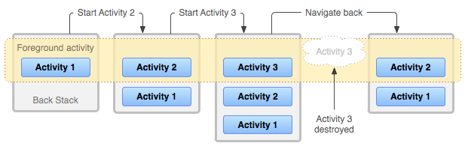

* What is a Service?

A Service is an application component that can perform long-running operations in the background and does not provide a user interface. Another application component can start a service and it will continue to run in the background even if the user switches to another application. Additionally, a component can bind to a service to interact with it and even perform interprocess communication (IPC). For example, a service might handle network transactions, play music, perform file I/O, or interact with a content provider, all from the background.